**Ideation Phase**

**Define the Problem Statements**

|  |  |
| --- | --- |
| Date | 13 October2022 |
| Team ID | PNT2022TMID52837 |
| Project Name | Early Detection of Chronic Kidney Disease using Machine Learning |

**Problem Statement :**

Patients can’t continuously monitor health conditions and they have difficulty in predicting chronic kidney disease that has fatal effects. They are unable to recognise symptoms in the earlier stages according to the disease. Hence, they are not able to predict and cure the disease.

**Example:**

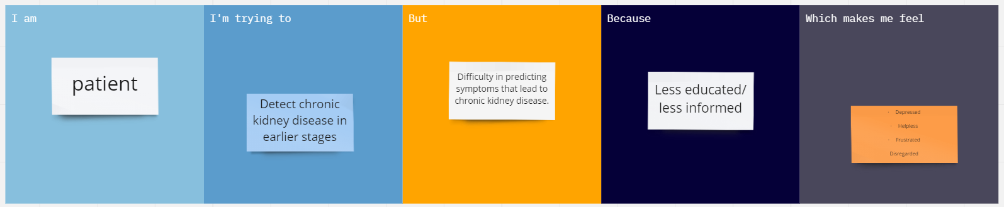

|  |  |  |  |  |  |
| --- | --- | --- | --- | --- | --- |
| **Problem Statement (PS)** | **I am (Customer)** | **I’m trying to** | **But** | **Because** | **Which makes me feel** |
| PS-1 | Patient | Detect chronic kidney disease in earlier stages | •Difficulty in predicting symptoms that lead to chronic kidney disease.  •No awareness regarding healthy lifestyle in accordance with the precautionary requirements of kidney diasease.  Can’t continuously monitor my health parameters. | * Less educated/ less informed * Less acquainted with modern technology | * Depressed * Helpless * Frustrated * Disregarded |